CURRICULAM VITAE

APPLYING FOR THE POST OF: 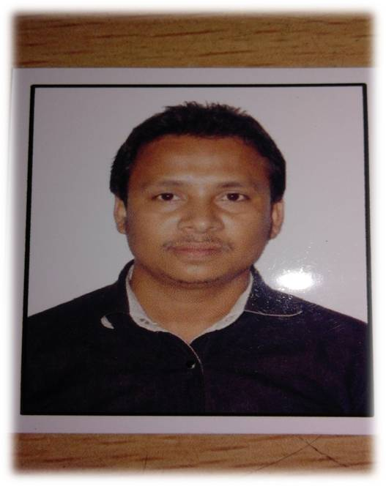

NAME: GYANDIP GOWALA

PRESENT ADDRESS
EMAIL ID: gowalagyandip@gmail.com
C/O: LATE UPEN GOWALA. MOBILE NO: +91-8486541510.
VILL/P.O: RONGAMATI. 7663899699.
DIST: GOLAGHAT.
STATE: ASSAM.
PIN: 785614. DATED:

CAREER OBJECTIVE:
- TO ASPIRE FOR A CAREER WHICH IS CHALLENGING AND TO ACHIVE GREAT HEGHT BY WORKING WITH AN ORGANISATION THAT GIVE SCOPE TO DEVLOP MY IDEA, KNOWLEDGE AND PERFOMANCE IN THIS FIELD WITH GREAT HARD WORK AND FULL DETERMINATION.

EDUCATIONAL QUALIFICATION:
- B.A. (GEOGRAPHY) FROM DIBRUGARH UNIVERSITY IN THE YEAR 2007.

TECHNICAL SKILL:
- COMPUTER BASIC KNOWLEDGE WITH INTERNATE BROWSING ETC.

TRAINNING ATTENDET:
- CALL CENTER TRAINNING PROGRAMME ATTENDET FOR THREE MONTHS.

LANGUAGE KNOWN:
- ASSAMESE, HINDI, ENGLISH.
CAPABILITY:
- TO COMMUNICATE DIFFERENT TYPES OF PEOPLE.
STREANGTH:
- ADAPTABLE.
- DYNAMIC.
- PUNCTUAL.
EXPERIENCE:
- 03 MONTHS EXPERIENCE IN CALL CENTER LIKE AIRCEL (DOMESTIC CALL CENTER) AT GUWAHATI
- EXPERIENCE IN HOTEL SUN VILLAGE (4 –STAR RANK)) AT GOA NEAR BAGHA BEACH.
PERSONAL DETAILS:
- FATHER’S NAME: LATE UPEN GOWALA.
- MOTHER’S NAME: MRS. BASANTI GOWALA.
- DATE OF BIRTH: 01.03.1982.

PERMANENT ADDRESS:
- VILL: RONGAMATI.
- P.O: RONGAMATI.
- DIST: GOLAGHAT (ASSAM).
- COUNTRY: INDIA.
- PIN: 785614.

HOBBIES:
- TRAVELLING AND PLYING COMPUTER GAMES.

DECLARATION
I DO HERE BY DECLARE THAT ALL THE ABOVE INFORMATION ARE TRUE TO BEST OF MY KNOWLEDGE. I SHALL RESPONSIBLE FOR ANY FALSE STATEMENT.

DATE: YOURS FAITHFULLY;

PLACE: (GYANDIP GOWALA).

